**Health Care Diabetes Detector Model Dashboard**

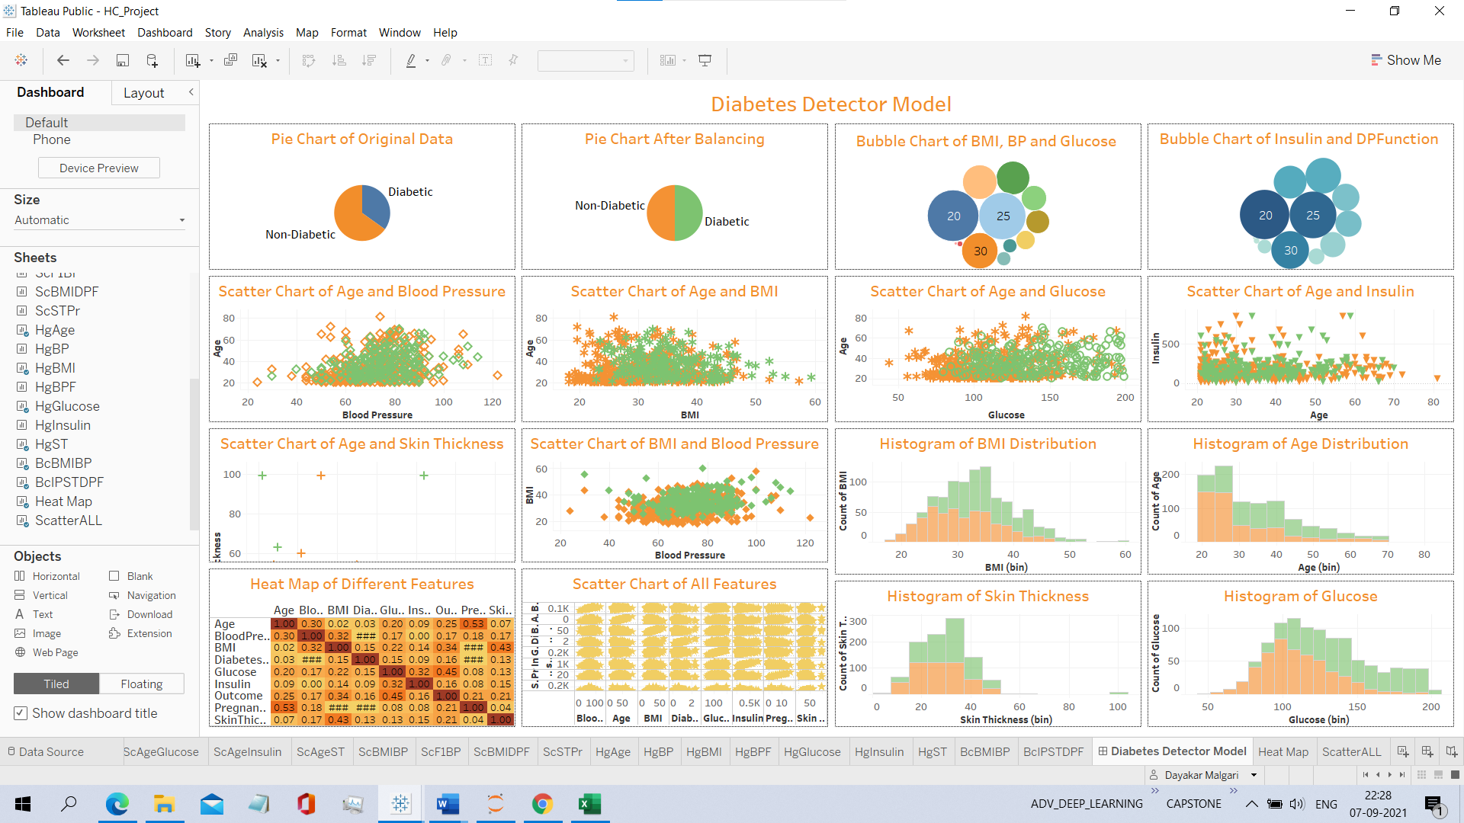

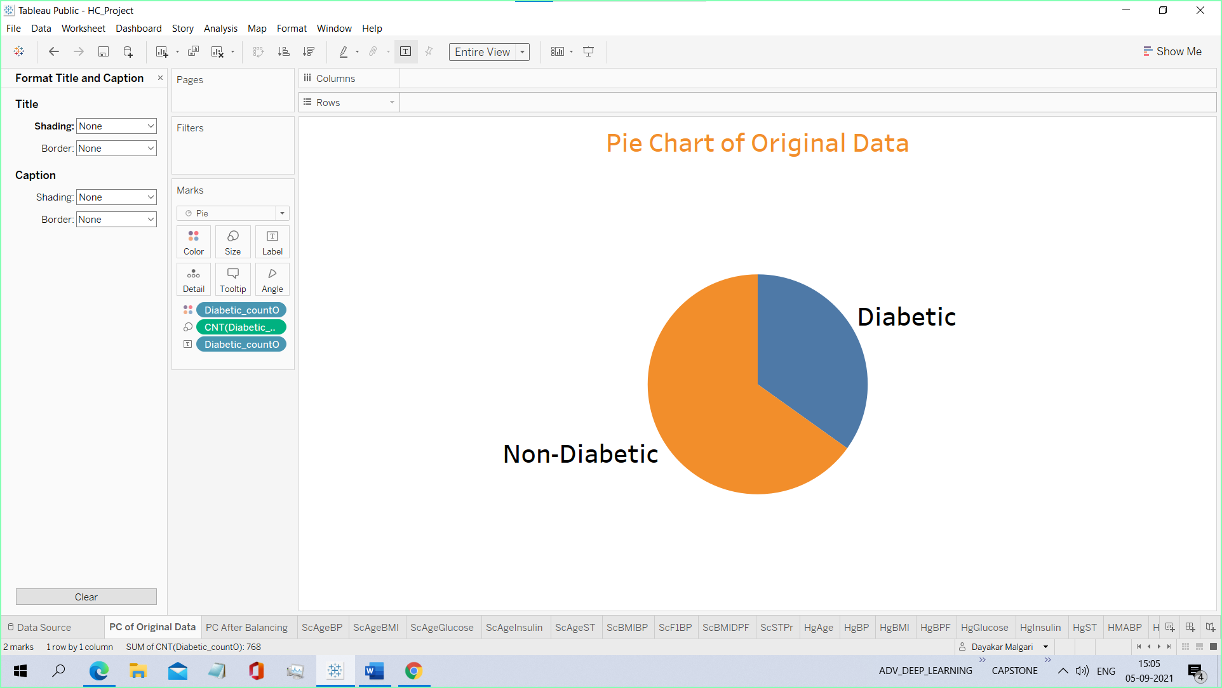**Pie chart of data before balancing**

